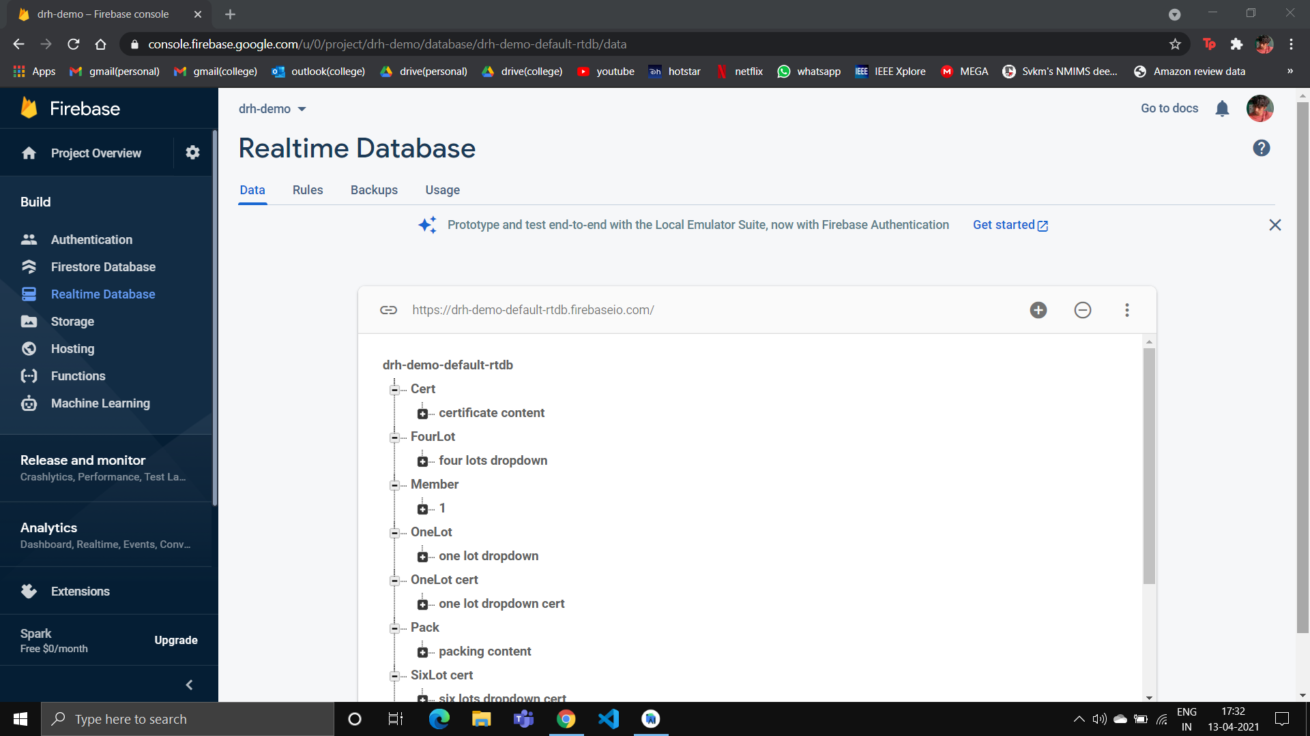

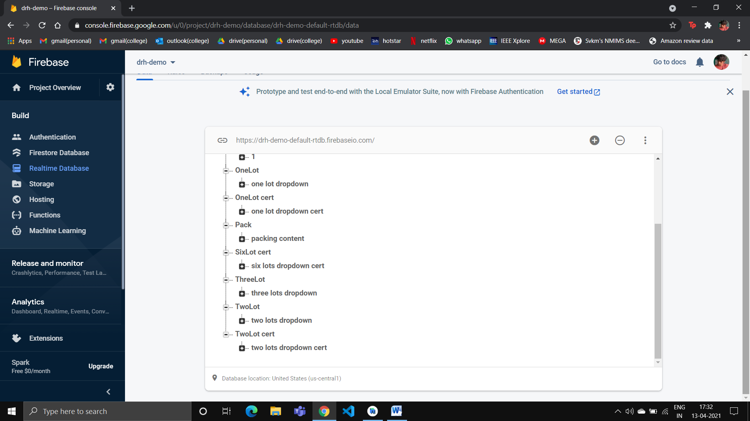

FIREBASE DATABASE .JSON FILE:

{

"Cert" : {

"certificate content" : {

"edit_text_quantity_cert" : 100,

"productname_cert" : "4-CPNA"

}

},

"FourLot" : {

"four lots dropdown" : {

"bag_pack_1" : 10,

"bag_pack_2" : 20,

"bag_pack_3" : 30,

"bag_pack_4" : 40,

"gross_pack_1" : 10,

"gross_pack_2" : 20,

"gross_pack_3" : 30,

"gross_pack_4" : 40,

"lot_pack_1" : 1,

"lot_pack_2" : 2,

"lot_pack_3" : 3,

"lot_pack_4" : 4,

"net_pack_1" : 10,

"net_pack_2" : 20,

"net_pack_3" : 30,

"net_pack_4" : 40,

"nobag_pack_1" : 10,

"nobag_pack_2" : 20,

"nobag_pack_3" : 30,

"nobag_pack_4" : 40,

"tare_pack_1" : 10,

"tare_pack_2" : 20,

"tare_pack_3" : 30,

"tare_pack_4" : 40

}

},

"Member" : [ null, {

"edit_text_quantity" : 100

} ],

"OneLot" : {

"one lot dropdown" : {

"bag_pack" : 10,

"gross_pack" : 10,

"lot_pack" : 1,

"net_pack" : 10,

"nobag_pack" : 10,

"tare_pack" : 10

}

},

"OneLot cert" : {

"one lot dropdown cert" : {

"appearance_cert" : "Complies",

"edit_text_appearance_cert_spec" : "xyz",

"edit_text_lot_cert" : 1,

"edit_text_purity_cert" : 99,

"edit_text_purity_cert_spec" : "xyz",

"edit_text_tlc_cert_spec" : "xyz",

"tlc_cert" : "Does not Comply"

}

},

"Pack" : {

"packing content" : {

"edit_text_name_pack" : "xyz",

"edit_text_packnumber_pack" : 10,

"edit_text_quantity_pack" : 10,

"edit_text_to_pack" : "xyz",

"productname_pack" : "CMBI"

}

},

"SixLot cert" : {

"six lots dropdown cert" : {

"appearance_cert" : "Complies",

"appearance_cert_2" : "Complies",

"appearance_cert_3" : "Complies",

"appearance_cert_4" : "Complies",

"appearance_cert_5" : "Complies",

"appearance_cert_6" : "Complies",

"edit_text_appearance_cert_spec" : "xyz",

"edit_text_lot_cert" : 1,

"edit_text_lot_cert_2" : 2,

"edit_text_lot_cert_3" : 3,

"edit_text_lot_cert_4" : 4,

"edit_text_lot_cert_5" : 5,

"edit_text_lot_cert_6" : 6,

"edit_text_purity_cert" : 99,

"edit_text_purity_cert_2" : 99,

"edit_text_purity_cert_3" : 99,

"edit_text_purity_cert_4" : 100,

"edit_text_purity_cert_5" : 99,

"edit_text_purity_cert_6" : 100,

"edit_text_purity_cert_spec" : "xyz",

"edit_text_tlc_cert_spec" : "xyz",

"tlc_cert" : "Complies",

"tlc_cert_2" : "Complies",

"tlc_cert_3" : "Complies",

"tlc_cert_4" : "Complies",

"tlc_cert_5" : "Complies",

"tlc_cert_6" : "Complies"

}

},

"ThreeLot" : {

"three lots dropdown" : {

"bag_pack_1" : 10,

"bag_pack_2" : 20,

"bag_pack_3" : 30,

"gross_pack_1" : 10,

"gross_pack_2" : 20,

"gross_pack_3" : 30,

"lot_pack_1" : 1,

"lot_pack_2" : 20,

"lot_pack_3" : 3,

"net_pack_1" : 10,

"net_pack_2" : 20,

"net_pack_3" : 30,

"nobag_pack_1" : 10,

"nobag_pack_2" : 20,

"nobag_pack_3" : 30,

"tare_pack_1" : 10,

"tare_pack_2" : 20,

"tare_pack_3" : 30

}

},

"TwoLot" : {

"two lots dropdown" : {

"bag_pack_1" : 10,

"bag_pack_2" : 20,

"gross_pack_1" : 10,

"gross_pack_2" : 20,

"lot_pack_1" : 1,

"lot_pack_2" : 2,

"net_pack_1" : 10,

"net_pack_2" : 20,

"nobag_pack_1" : 10,

"nobag_pack_2" : 20,

"tare_pack_1" : 10,

"tare_pack_2" : 20

}

},

"TwoLot cert" : {

"two lots dropdown cert" : {

"appearance_cert" : "Complies",

"appearance_cert_2" : "Does not Comply",

"edit_text_appearance_cert_spec" : "xyz",

"edit_text_lot_cert" : 1,

"edit_text_lot_cert_2" : 2,

"edit_text_purity_cert" : 99,

"edit_text_purity_cert_2" : 99,

"edit_text_purity_cert_spec" : "xyz",

"edit_text_tlc_cert_spec" : "xyz",

"tlc_cert" : "Complies",

"tlc_cert_2" : "Complies"

}

}

}